**Agency Appointments by Licensed State**

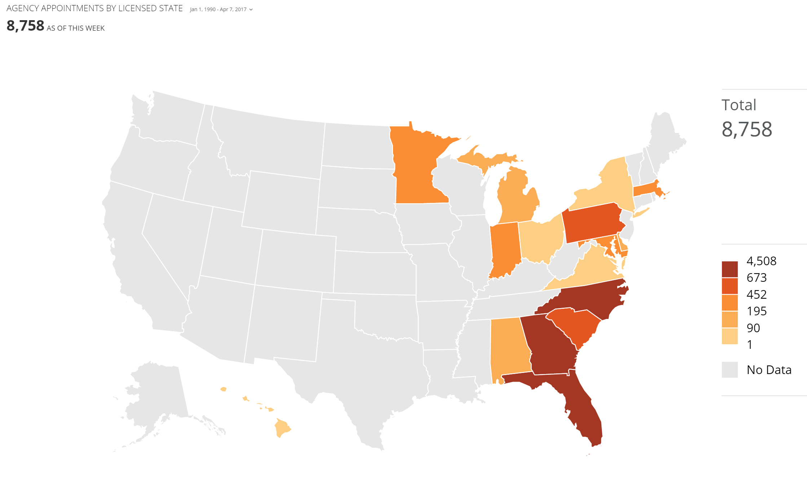

**Policy Survival % YOY by State/County/Zip**

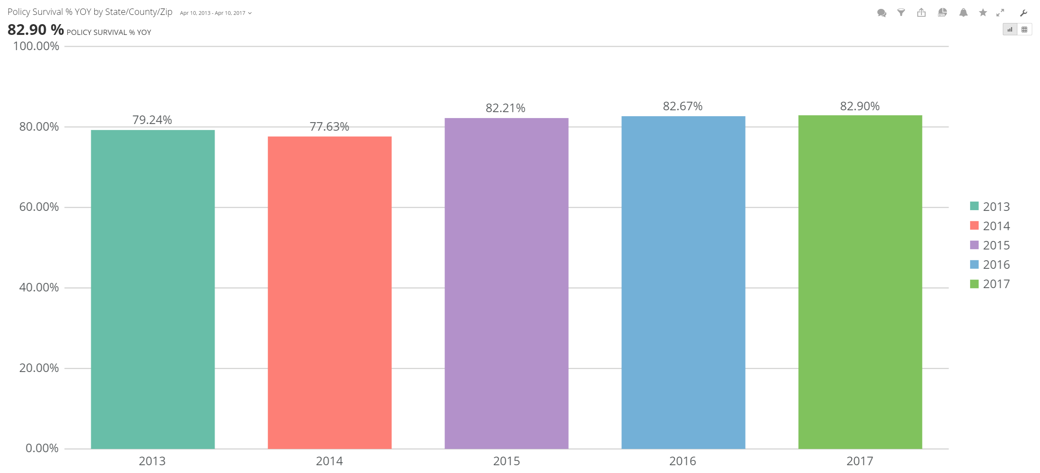

**Agency Retention % YOY by State/County/Zip**

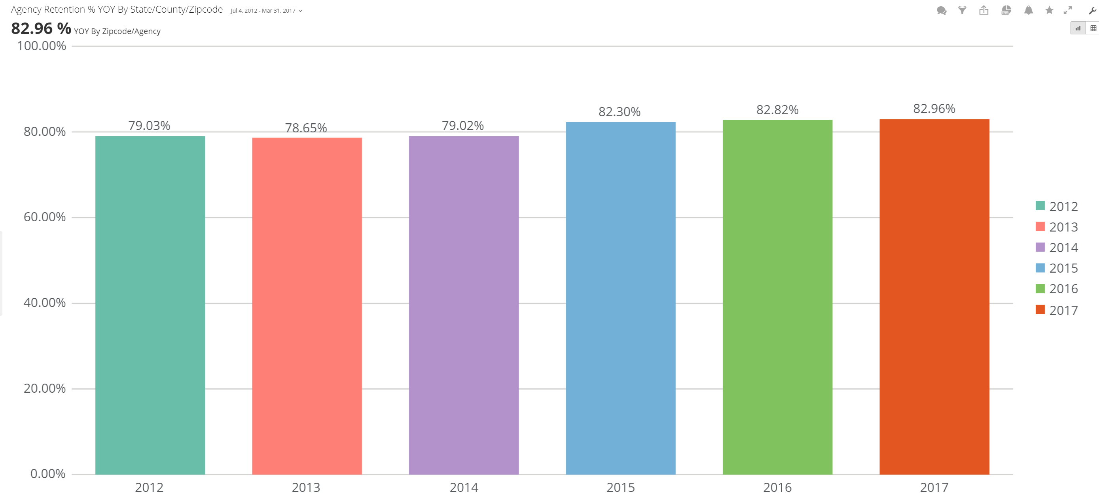

**Top 25 Agencies by Premium by Week**

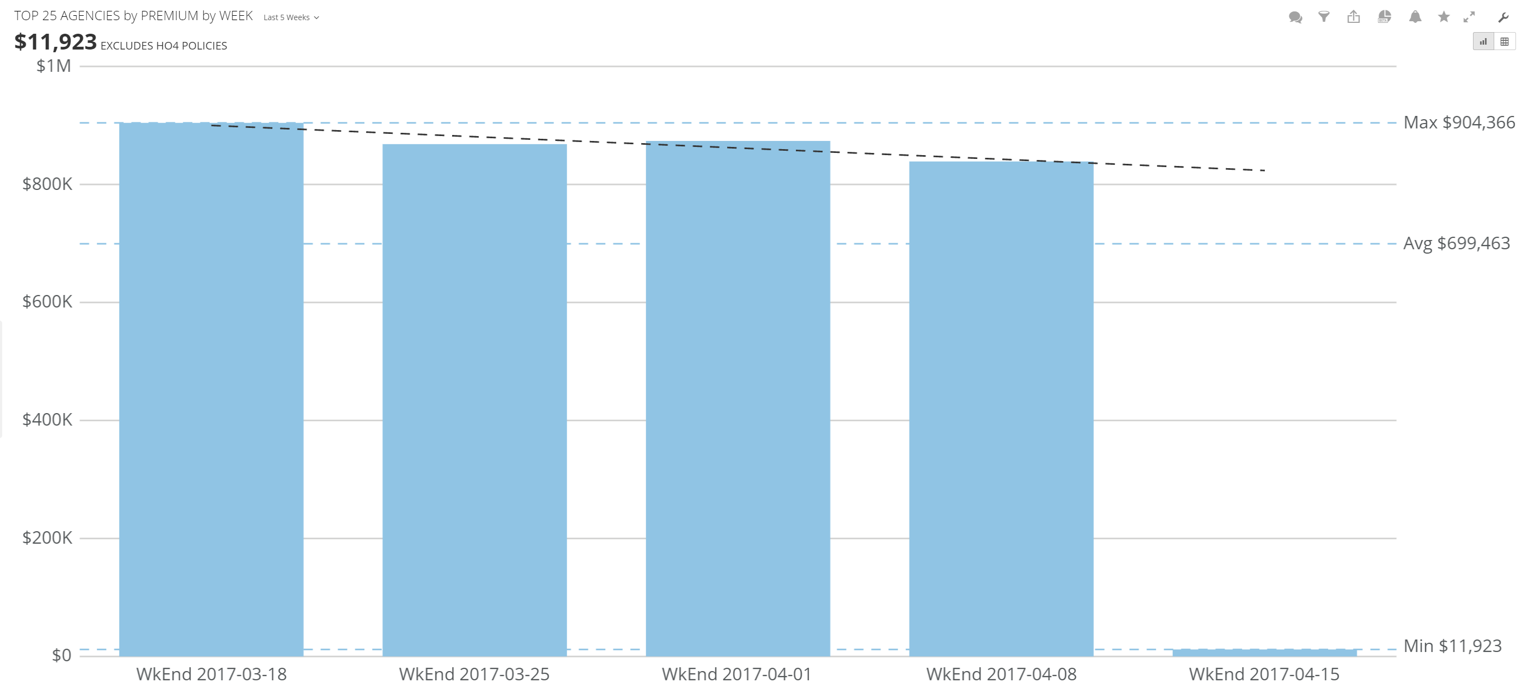

**WOW Policy’s Submitted By Premium**

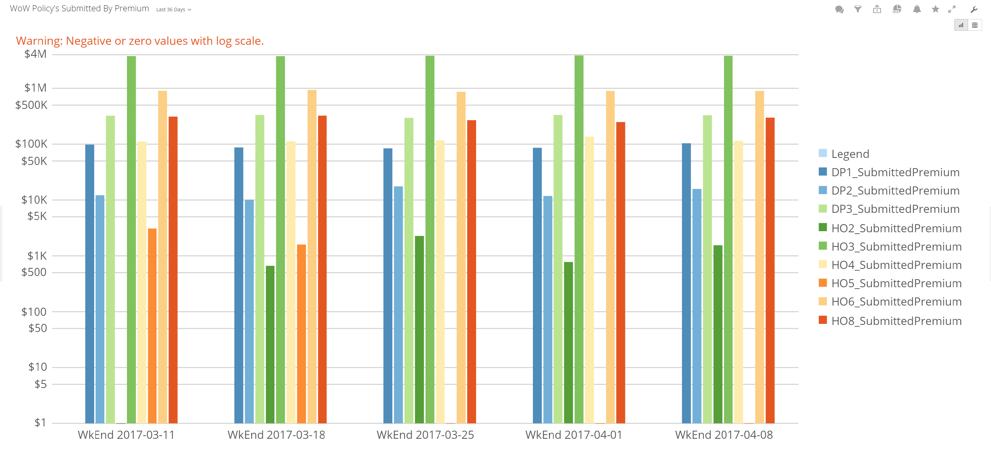

**New Written Premium by State/Agency**

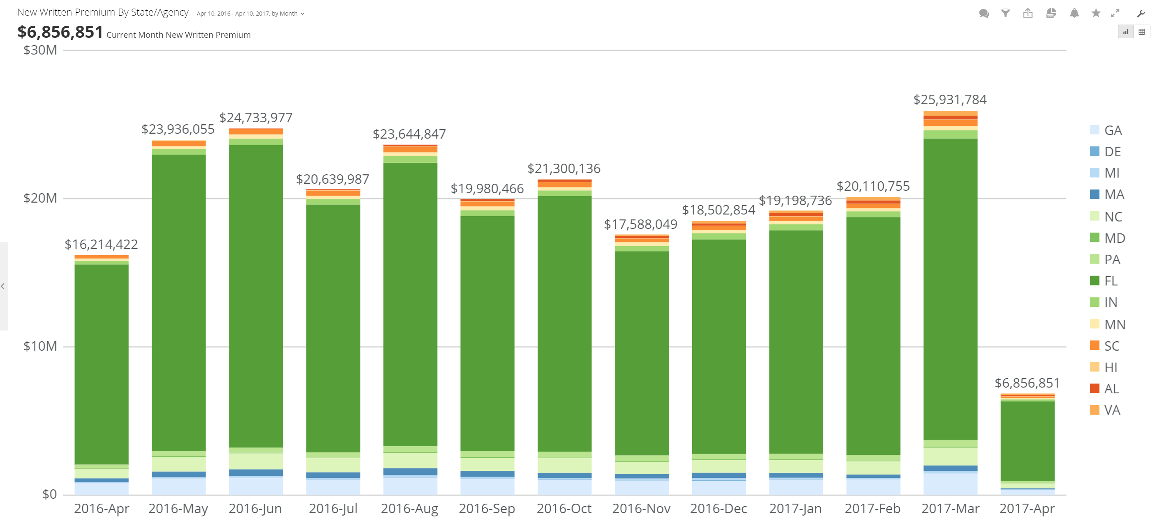

% Change – New Written premium

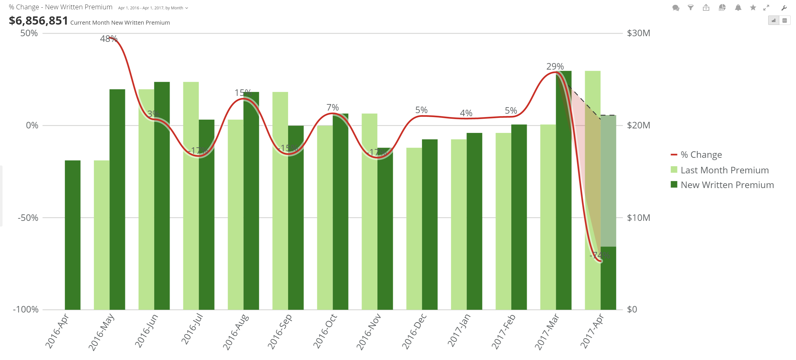

Top 25 YTD YOY Premium Growth by Agency

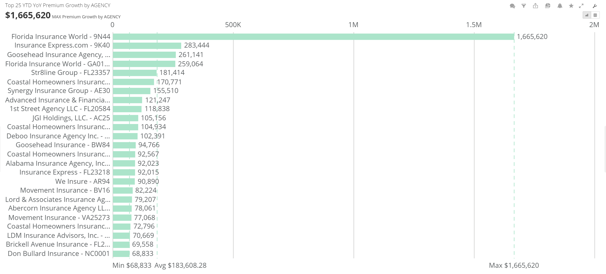

**Top 25 YTD YOY Agency Premium Growth by Rep**

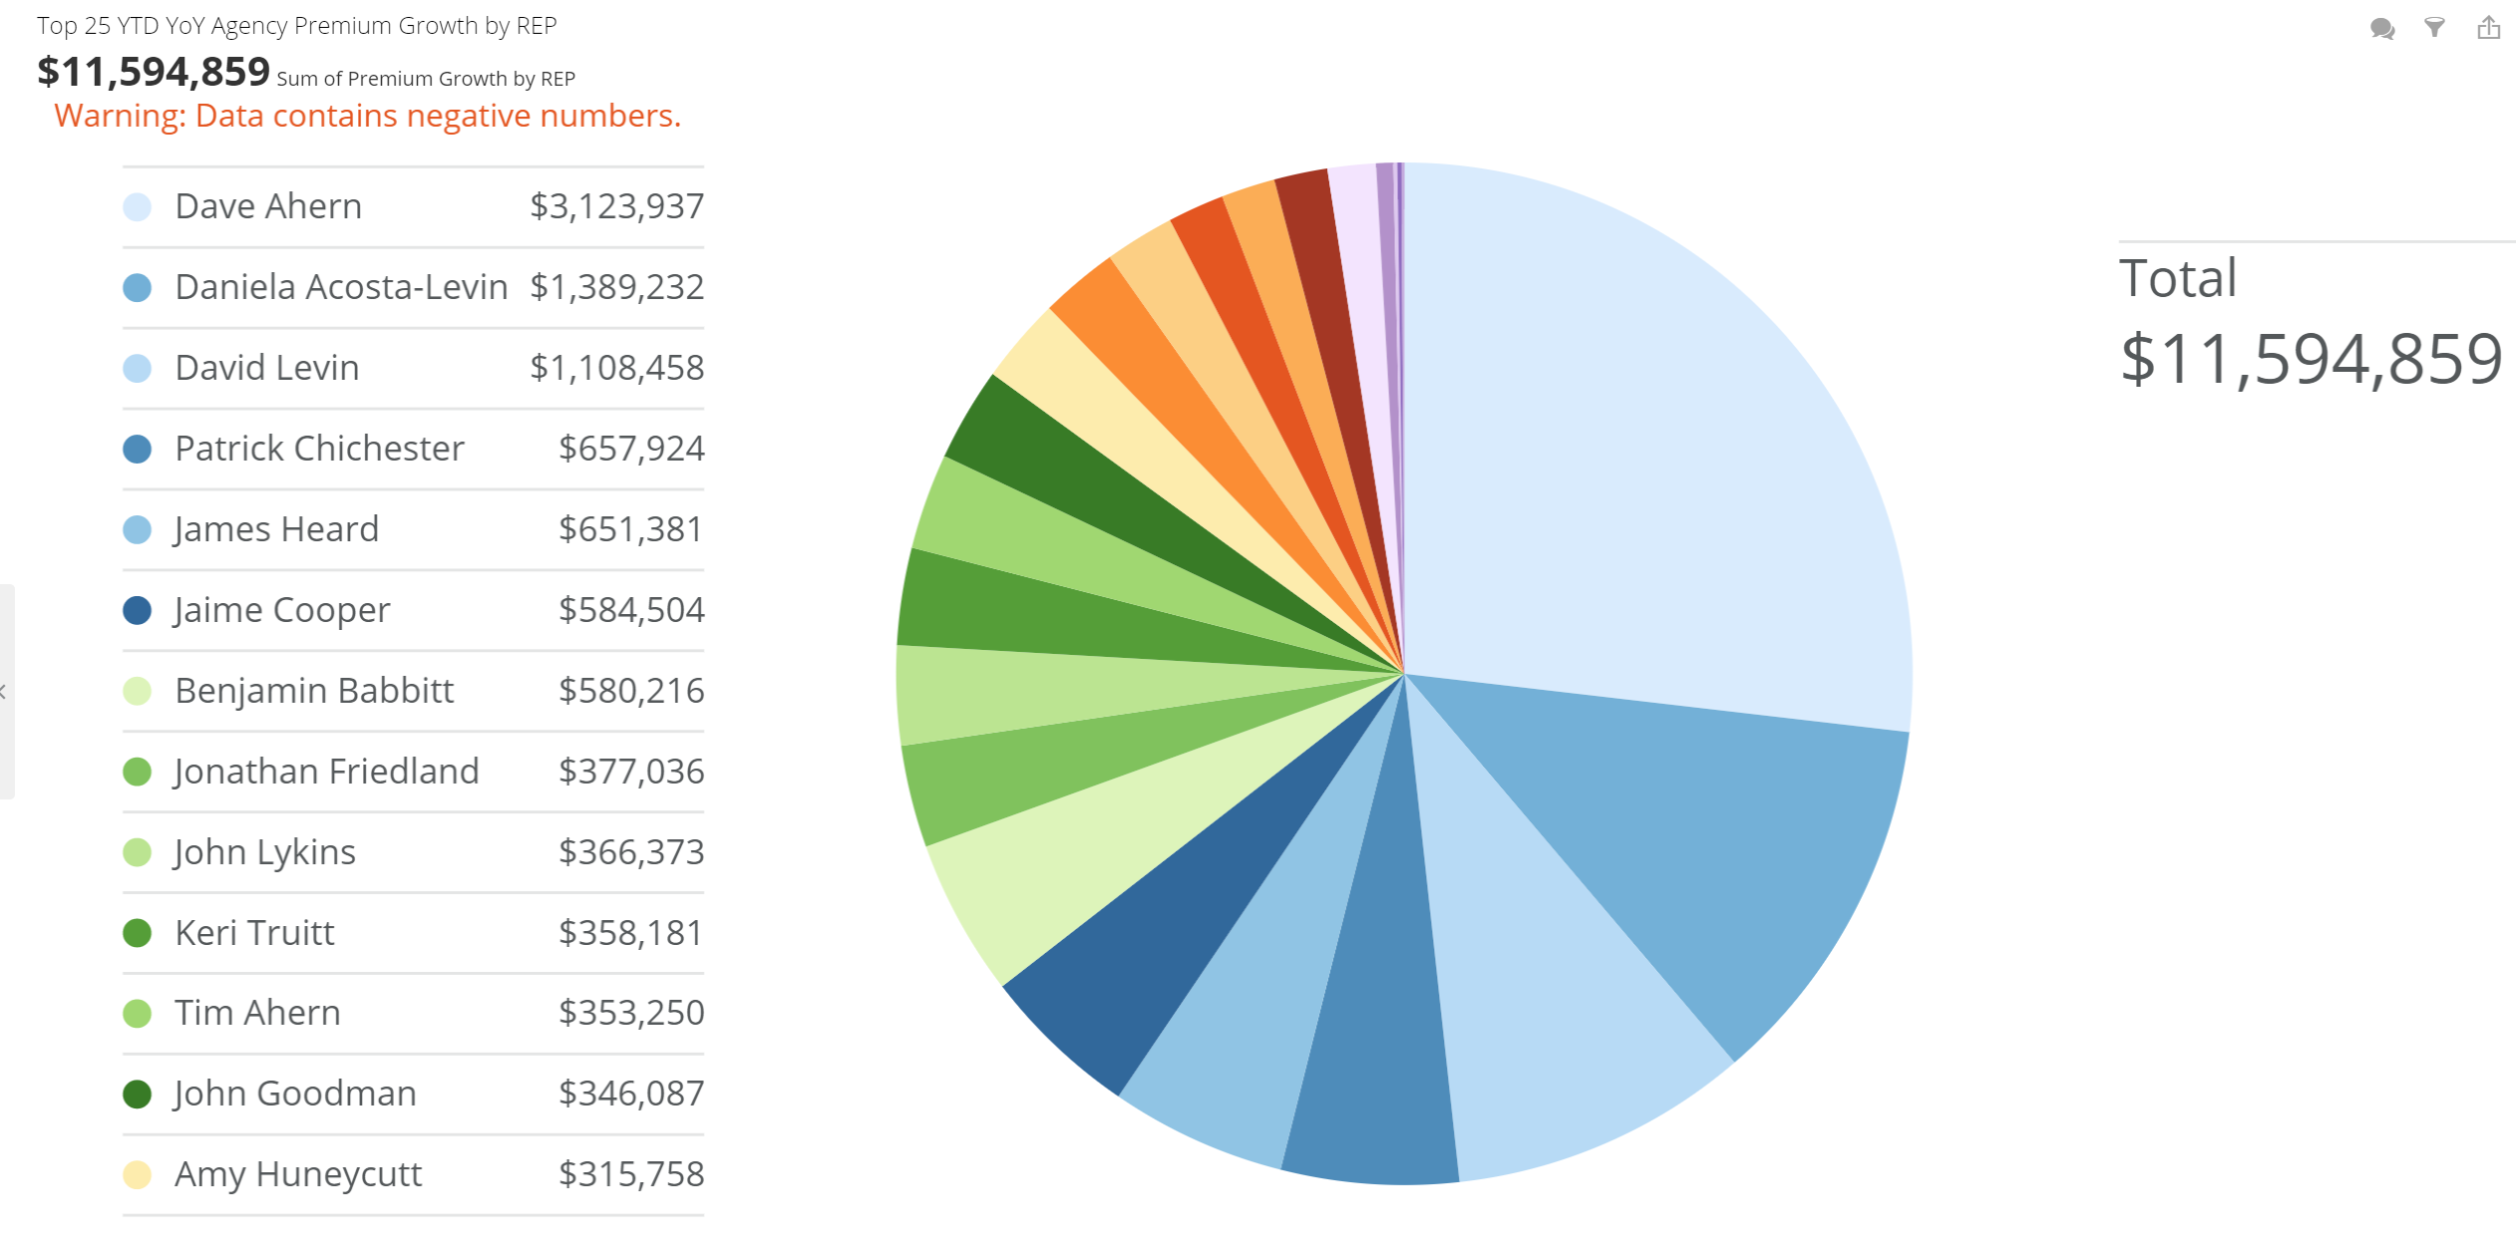

YTD Claim Count by County

